**3. EXISTING SYSTEM**

**3.1 USING 1D DCT**

The image of size is divided into rows and concatenates these rows to form a 1D vector data whose size would be as shown in Fig.1a. The Matlab code for this is:

function[R] = c2dt1d(R,m,n)

% conversion from 2D array to 1D vector

% input=> R: 2D image/array, m: no. of rows and n: no. of columns

% output=> R: 1d vector data

R(2:2:end,:)=R(2:2:end,end:-1:1);

R = reshape(R',1,m*n);

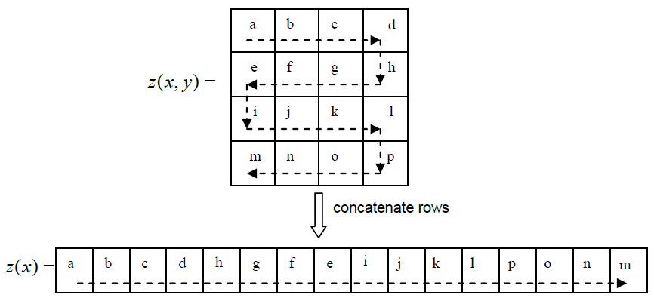

**Figure 3.1:** Concatenation of rows to convert 2D image into 1D vector data

The 2D image can be reconstructed from the 1D vector data by reversing the

procedure outlined in Figure 1a and the corresponding Matlab code is:

function[R] = c1d2d(R,m,n)

% conversion from 1D vector to 2D array

% input=> R: 1d vector data, m: no. of rows and n: no. of columns

% output=> R: 2D image/array

R = reshape(R,n,m)';

R(2:2:end,:)=R(2:2:end,end:-1:1);

Similarly, the image z(x, y)of size MxN is divided into columns and concatenates these columns to form a 1D vector data z(x)whose size would be MN as shown in Fig.1b. The Matlab code is: R= c2dt1d(R',m,n);

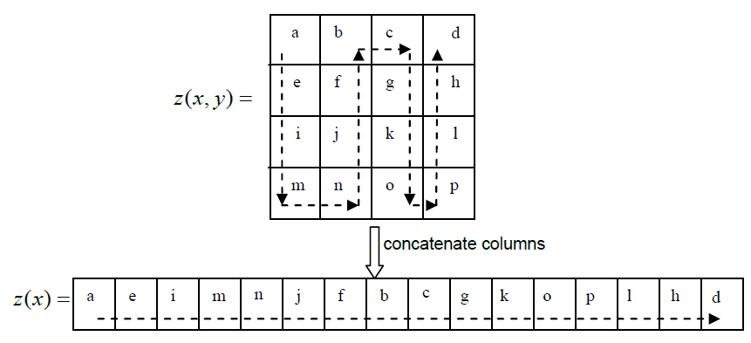

**Figure 3.2:** Concatenation of columns to convert 2D image into 1D vector data

Fusion process is done on both row and column images separately and averaged together to avoid any noise or distortion introduced in the fusion process.

**3.1.1 Frequency Partition (FP)**

One dimensional (1D) DCT is applied on vector data and patrician the DCT coefficients into low frequency (LF) and high frequency (HF) components with a partition factor as shown in Figure 2 using energy compaction property of DCT coefficients.

Z(u)=DCT(z(x)),x,u=0,1,2,3,……,MN-1 (3a)

ZL(u)=Z(u),u=0,1,2,3,……,MNf-1 (3a)

ZH(u)=Z (u),u=MNf,MNf+1, ……,MN-1 (3a)

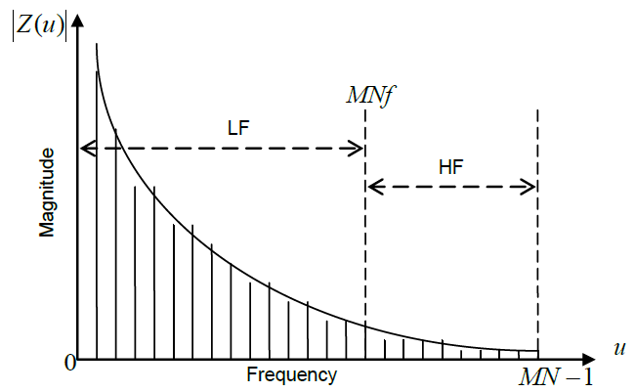

**Figure 3.3:** Separation of LF & HF coefficients

Let the images to be fused are z1(x,y)&z2(x,y)and the image fusion process is as follows:

Z1(x)=c2dt1d(z1(x,y),M,N) (4a)

Z2(x)=c2dt1d(z2(x,y),M,N) (4b)

Z1(u)=DCT (z1(x)) (4a)

Z1(x)=DCT (z2(x)) (4a)

Using eq.3, the fused coefficients are:

ZLf(u)=0.5(ZL1(u)+ ZL2(u)+ ZL3(u)),u=0,1,2,3,……MNf-1 (5a)

formula5b (5b)

Zf(u)=[ZLf(u) ZHf(u)] (5c)

Zf(x)=idct(Zf(u)),x,u=0,1,2,3,………..,MN-1 (5d)

The fused image is:

If=c1dt2d(zf(x),M,N) (5e)

Where the subscript 1 or 2or f indicates 1st or 2nd or fused image respectively.

**3.1.2 Multi-resolution DCT (MSDCT)**

The multi-resolution analysis is illustrated in Figure 3. The vector data is passed through DCT. Consider first half of the DCT coefficients as LF and the remaining as HF coefficients. The LF coefficients are passed through IDCT to get the vector data for next level of decomposition as shown in

Figure 3. Let zk(x)=z(x) at k=1 level and at each kth level:

Zk(u)=dct(zk(x)), x,u=0,1,……, $\frac{MN}{2k-1}-1$ (6a)

ZLk(u)=Zk(u), u=0,1,2,……, $\frac{0.5*MN}{2k-1}-1$ (6b)

ZHk(u)=Zk(u), u= $\frac{0.5MN}{2k-1}-1,\frac{0.5MN}{2k-1}-1,.…,MN-1$ (6c)

Zk+1(x)=idct(ZLk(u)) (6d)

Where the subscript k indicates multi resolution decomposition level.

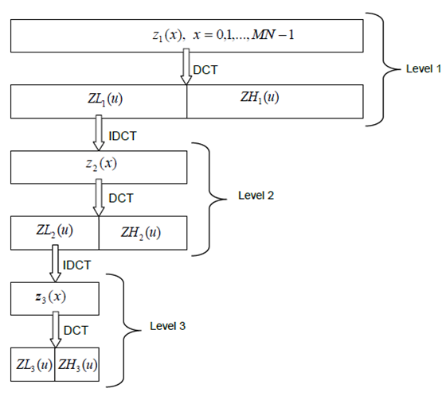

**Figure 3.4:** Multi resolution image analysis using 1D DCT

Let the images to be fused are z1(x,y) & z2(x,y) and the image fusion process is as follows. Using eq.4 and 6, the fused coefficients are:

ZLkf(u)=0.5(ZLk1(u)+ ZLk2(u)), u=0,1,….,0.5 $\frac{MN}{2k-1}-1$ k=K (7a)

**3.2 FUSION QUALITY EVALUATION METRICS**

Fusion quality can be evaluated visually. Human judgment decides fusion quality. Human object evaluators give grade to corresponding image (fused) and average the grade. This type of evaluation has some drawbacks such as the grade is not accurate and it depends on the human observer’s ability. To avoid these drawbacks, quantitative measures are used for accurate and meaningful assessment of fused images.

**3.2.1 Percentage Fit Error (PFE)**

PFE is computed as the norm of the difference between the corresponding pixels of reference and fused image to the norm of the reference image. This will be zero when both reference and fused images are exactly similar and it will be increased when the fused image is deviated from the reference image. The PFE is computed as:

PFE= $\frac{norm(Ir-If)}{norm(Ir)}*100$

where is the operator to compute the largest singular value norm

**3.2.2 Peak Signal to Noise Ratio (PSNR)**

PSNR will be high when the fused and reference images are alike. Higher value means better fusion. It is computed as:

PSNR=20log10[$\frac{L2}{\frac{1}{MN}\sum_{i=1}^{M}{\sum_{i=1}^{M}{(}Ir\left(i,j\right){-If(i,j))}^{2}}1}$]

where in the number of gray levels in the image L

**3.2.3 Standard Deviation (SD)**

It is known that standard deviation is composed of the signal and noise parts. This metric would be more efficient in the absence of noise. It measures the contrast in the fused image. An image with high contrast would have a high standard deviation.

$σ=\sqrt{\sum_{i=0}^{l}{{\left(i-i^{'}\right)}^{2}h_{tf}\left(i\right),}}$ $i^{'}=\sum_{i=0}^{L}{ih_{tf}}$

**3.2.4 Spatial Frequency (SF)**

SF indicates the overall activity level in the fused image. The spatial frequency for the fused image If of dimension MxN is defined as follows:

Row frequency:

C:\Users\Lokesh\Pictures\sf1.PNG

Column frequency:

C:\Users\Lokesh\Pictures\sf2.PNG

Spatial frequency

C:\Users\Lokesh\Pictures\sf3.PNG

**3.3 RESULTS AND DISCUSSION**

The fusion algorithms developed in section 3 are evaluated using the images shown in Figure 3.5. The ground truth image is shown in Figure 3.5a and the images to be fused are shown in Figure 3.5b&c. Both Figure 3.5b and Figure 3.5c are complementary to each other. In first image ( *I*1 ) upper side aircraft is out of focused and the other aircraft is in focus as shown in Figure 7b and vice versa in image *I* 2 as shown in Figure 3.5c. The out of focus has been created by blurring the portions of the reference image with a Gaussian mask using diameter of 12 pixels. The fused (left side) along with the error (right side) images are shown in Figure 3.6 to 3.8. The error image is the difference between reference Ir and If images. One can observe that the fused image preserves all the useful information from the two source images. The fusion quality evaluation metrics are shown in Table 1 to 6. The best results are shown in bold. In case of 1D DCT based image fusion techniques, the Laplacian pyramid based image fusion gives better results with high levels of decomposition. It could be because of series of quasi- band passed images which are localized in both space and spatial frequencies. Similarly, SD and SF are high that shows that the fused image having good contrast and retain the overall activity.

(a)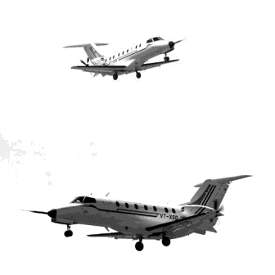

**Figure 3.5a:** Ground truth image

(b) 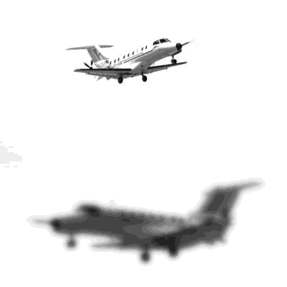 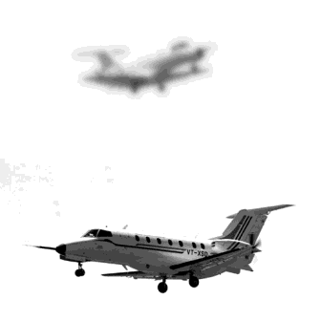(c)

**Figure 3.5b&c:** Images to be fused

**Table 3.1:** Fusion quality evaluation metrics for frequency partition

|  |  |  |  |  |  |  |
| --- | --- | --- | --- | --- | --- | --- |
|  | Partition scale factor ( *f* ) | | | | | |
| 0.0 | 0.2 | 0.4 | 0.6 | 0.8 | 1.0 |
| PFE | **3.0913** | 3.6284 | 3.8935 | 3.9818 | 4.0095 | 4.0194 |
| PSNR | **39.5879** | 38.8922 | 38.5859 | 38.4886 | 38.4584 | 38.4478 |
| SD | **48.9726** | 46.3338 | 46.0018 | 45.9041 | 45.8739 | 45.8628 |
| SF | **15.4065** | 12.7195 | 11.0493 | 9.9335 | 9.3618 | 9.0953 |

**Table 3.2:** Fusion quality evaluation metrics for 1D multi-resolution DCT

|  |  |  |  |  |  |
| --- | --- | --- | --- | --- | --- |
|  | No. of decomposition levels ( *K* ) | | | | |
| 1 | 2 | 3 | 4 | 5 |
| PFE | 3.9508 | 3.7245 | 3.3793 | 3.0959 | **3.0593** |
| PSNR | 38.5225 | 38.7786 | 39.2011 | 39.5815 | **39.6332** |
| SD | 45.9385 | 46.2037 | 46.6796 | 47.2891 | **47.8383** |
| SF | 10.4128 | 12.2229 | 13.4712 | 14.2075 | **14.7721** |

**Table 3.3:** Fusion quality evaluation metrics for LP1D

|  |  |  |  |  |  |
| --- | --- | --- | --- | --- | --- |
|  | No. of pyramid levels ( *K* ) | | | | |
| 1 | 2 | 3 | 4 | 5 |
| PFE | 3.8937 | 3.4647 | 2.7186 | 1.8675 | **1.4672** |
| PSNR | 38.5858 | 39.0927 | 40.1458 | 41.7767 | **42.8246** |
| SD | 45.9673 | 46.3366 | 46.9828 | 47.8254 | **48.5444** |
| SF | 10.8488 | 13.1805 | 14.7043 | 15.5537 | **16.1210** |

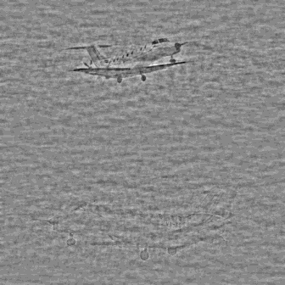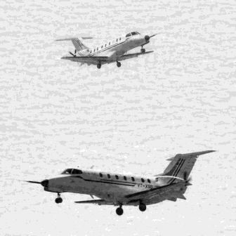

**Figure 3.6:** Fused and error image using frequency partition technique

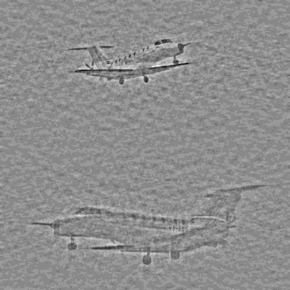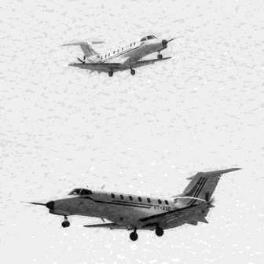

**Figure 3.7:** Fused and error image using frequency 1D multi-resolution analysis(MSDCT)

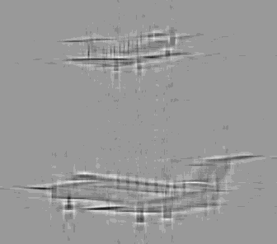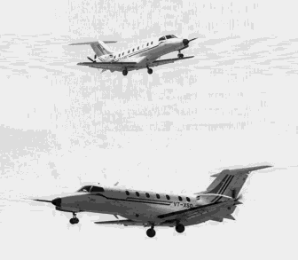

**Figure 3.8:** Fused and error image using Laplacian pyramid analysis